Brief Guide to Rally Point Scoring in BDBA

Scoring

In accordance with BDBA League Competition Rule League Match Games will normally be played to 21 points, unless the score reaches 20-20 in which case the game goes into extended play and play must continue until one side is two clear points ahead. (e.g. 27-25 etc) (Extended play is not optional - it is compulsory if the game reaches 20-20)
If the score reaches 29-29 then the side obtaining 30 points first is the winner.

In accordance with Cup Competition Rule Cup Match Games will be played to 21 points with no extended play.

One point will be received by the side winning the rally, this includes service faults.

Serving

In the traditional scoring system, each side had 2 servers per service round except at the start of a game. In Rally Point Scoring (RPS), a side has only one server per service round.

The service passes between the two sides alternately.

At the beginning of the game and when the score is even, the server serves from the right service court. When it is odd, the server serves from the left court.

- If the serving side wins a rally, the serving side scores a point. The same server serves again from the alternate service court (i.e. serving side swap sides)

- If the receiving side wins a rally, the receiving side scores a point. The receiving side becomes the new serving side (i.e. neither side swap sides)

When the service returns to your side, the correct person should be stood in the correct service court (Right hand court for even scores, left hand court for odd scores)

By following the above, players will serve in the same sequence throughout a game, as follows:
Initial Server
Initial Receivers Partner
Initial Servers Partner
Initial Receiver

Example

In this doubles match A & B are playing against C & D.

A & B won the toss and decided to serve.

A (the initial server) is about to serve to C (the initial receiver)

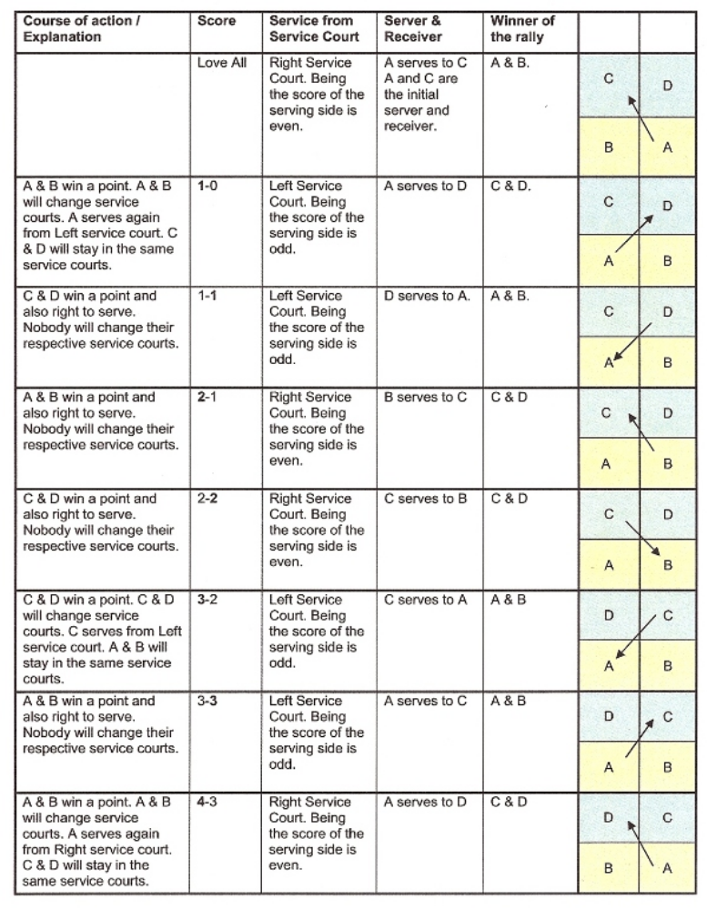
and so on…..

